Software Requirements
Specification

for

Margdarshi (Indian Railway Traffic Management System)

Prepared by: Rishabh Pandey (2024BCS0158), Rohan Jose (2024BCS0122), Vineeth M N (2024BCS0178), Tejas Varma (2024BCS0094)

Group Details:

Rishabh Pandey | Coder | rishabhpandey24bcs0158@iiitkottayam.ac.in
Rohan Jose  Vineeth M N  Tejas Varma | Team Lead  SW Architect  SW Tester | Rohanjose24bcs0122@iiitkottayam.ac.in  Vineethn24bcs0178@iiitkottayam.ac.in  Varmasurendra24bcs94@iiitkottayam.ac.in

Instructor: | Dr. Athira B
Course: | Software Architecture
Lab Section: | 01
Date: | 28st July, 2026

Contents

CONTENTS II
MARKET COMPETITION III
- INTRODUCTION 1
  - Document Purpose 1
  - Product Scope 1
  - Intended Audience and Document Overview 1
  - Definitions, Acronyms and Abbreviations 2
  - Document Conventions 3
  - References and Acknowledgments 4
- OVERALL DESCRIPTION 5
  - Product Overview 5
  - Product Functionality 5
  - Design and Implementation Constraints 5
  - Assumptions and Dependencies 7
- SPECIFIC REQUIREMENTS 9
  - External Interface Requirements 9
  - Functional Requirements 12
  - USE CASE MODEL …………………………………...
- OTHER NON-FUNCTIONAL REQUIREMENTS 14
  - Performance Requirements 14
  - Safety and Security Requirements 15
  - Software Quality Attributes 16
- UML DIAGRAMS …………………………………………18
  - Sequence Diagram 18
  - Activity Diagram 19
  - State Chart Diagram 20
  - Usecase Diagram 21
  - Data Flow Diagram 22
APPENDIX A – DATA DICTIONARY 24
APPENDIX B - GROUP LOG 27

Market Competition

Product | Organization | Key Features | Limitations | Our Advantage
Control Office Application (COA) | Indian Railways | Train scheduling, train movement monitoring, centralized railway control | Limited AI capabilities, minimal predictive analytics, relies heavily on manual decision making | AI-driven conflict detection, predictive recommendations, GIS visualization, simulation engine
Rail Traffic Management System (RTMS) | Indian Railways / CRIS | Real-time monitoring, train dispatching, centralized operations | Limited optimization algorithms, lacks advanced "what-if" simulations | Machine learning-based optimization with intelligent traffic recommendations
Siemens Mobility Rail Automation | Siemens Mobility | Automatic train control, signaling, digital railway management | Expensive deployment, designed primarily for signaling infrastructure | Open-source architecture, lower implementation cost, compatible with legacy railway databases
Hitachi Rail Traffic Management | Hitachi Rail | Network management, timetable optimization, dispatch support | High licensing and infrastructure costs, less customizable | AI-assisted recommendations with seamless integration into existing Indian Railway infrastructure
Alstom ICONIS Traffic Management | Alstom | Centralized traffic control, route planning, operational analytics | Focuses mainly on large-scale enterprise deployments | Designed specifically for Indian Railways with legacy COA integration and localized workflows
Wabtec Precision Dispatch System | Wabtec | Freight scheduling, dispatch optimization, network visibility | Primarily optimized for freight operations | Supports both passenger and freight traffic with predictive AI and KPI dashboards

1 Introduction

Document Purpose
This Software Requirements Specification (SRS) document details the functional and non-functional requirements for Margdarshi (Indian Railway Traffic Management System), Version
1.0. The purpose of this document is to provide a definitive technical and operational roadmap for the development team, railway administrators, and traffic controllers. It outlines the system’s capabilities, ranging from real-time data ingestion to AI-driven decision support, ensuring that all stakeholders have a shared understanding of the project’s objectives and technical boundaries.

The scope of this SRS covers the entire Margdarshi ecosystem, including the real-time GIS-based live tracking interface, the AI-powered recommendation engine, the block occupancy conflict detection module, and the "what-if" simulation suite. While the system is designed to integrate with existing Indian Railway legacy databases and signalling hardware, this document specifically focuses on the software logic, user interfaces, and data processing layers required to transform raw railway data into actionable traffic management insights.

  - Product Scope
Margdarshi is an intelligent, real-time traffic management system designed specifically for the Indian Railways to modernize and optimize network operations. The software serves as a decision-support platform that integrates live train tracking data and block occupancy status into a unified GIS-based interface. Its primary purpose is to provide traffic controllers with AI-assisted recommendations and "what-if" simulation tools, enabling them to manage complex rail traffic with higher precision. By utilizing automated conflict detection and performance dashboards, the system transitions railway management from reactive manual monitoring to proactive, data-driven orchestration.

The implementation of Margdarshi offers significant strategic and operational benefits. The core objective is to minimize delays and maximize block utilization, directly improving the punctuality of the rail network. From a safety perspective, the system’s ability to detect potential track occupancy conflicts in real-time serves as a critical fail-safe, reducing the risk of human error. Furthermore, the product aims to boost overall network efficiency by providing a clear visualization of Key Performance Indicators (KPIs), allowing administrators to identify bottlenecks and optimize resource allocation. Ultimately, Margdarshi aligns with the goals of Indian Railways to provide a safer, more reliable, and technologically advanced transportation infrastructure.

Intended Audience and Document Overview
This document is designed for a diverse set of stakeholders involved in the modernization of the Indian Railway traffic management system. The primary audience includes:
    - The Client (Indian Railways Administration): To verify that the proposed system meets the operational goals of increasing punctuality, safety, and block utilization.
    - The Professor/Academic Supervisor: To evaluate the technical rigor, feasibility, and adherence to software engineering standards.
    - Development Team & System Architects: To use as a technical blueprint for building the AI engine, GIS maps, and legacy system integrations.
    - Traffic Controllers (End-Users): To understand the functional tools, such as the simulation suite and KPI dashboards, that will assist their daily decision-making.
    - Quality Assurance (Testers): To derive test cases ensuring the system handles real-time data and conflict detection accurately.

The document is organized into four main sections. Section 1 (Introduction) provides the high-level vision and scope. Section 2 (Overall Description) describes the product perspective, user classes (such as controllers and administrators), and the operating environment. Section 3 (Specific Requirements) contains the detailed functional requirements for the AI recommendations and live tracking, as well as external interface requirements. Finally, Section 4 (Non-functional Requirements) details the security, legal compliance, and safety standards essential for railway operations.

Suggested Reading Sequence:
    - Railway Administrators and Professors should prioritize Sections 1 and 2 to understand the strategic value and feasibility.
    - Developers and Architects should focus on Section 3 and the "Technical Risks" mentioned in the project overview to understand implementation challenges.
    - Testers and End-Users should concentrate on Section 3 (Functional Requirements) and the appendices to understand the specific workflows and data handling of the Margdarshi system.

Definitions, Acronyms and Abbreviations

The following list defines the terms, acronyms, and abbreviations necessary to interpret this document correctly:
    - AI (Artificial Intelligence): The simulation of human intelligence processes by computer systems, used in Margdarshi to provide traffic optimization recommendations.
    - Block Occupancy: A status indicating whether a specific section of a railway track (a "block") is currently occupied by a locomotive or train.
    - Conflict Detection: The automated process by which the system identifies two or more trains scheduled to occupy the same track block simultaneously.
    - GIS (Geographic Information System): A framework for gathering, managing, and analysing data; used here for the live railway maps and real-time train tracking.
    - Human-in-the-Loop: A model of interaction where the AI provides recommendations, but a human controller makes the final decision, ensuring safety and oversight.
    - Indian IT Laws: The legal framework (primarily the Information Technology Act, 2000) governing cyber activities and data protection in India.
    - KPI (Key Performance Indicator): Quantifiable measures used to evaluate the success of railway operations, such as punctuality, average speed, and block utilization rates.
    - Legacy Systems: Older, existing railway computer systems and signalling infrastructure that Margdarshi must integrate with.
    - Live Tracking: The real-time visualization of train geographical coordinates and movement status.
    - Margdarshi: The name of the proposed Intelligent Traffic Management System (the "Product").
    - Punctuality: The measure of trains arriving and departing according to the established schedule.
    - SRS (Software Requirements Specification): This document, which describes the functional and non-functional requirements of the system.
    - "What-if" Simulation: A tool that allows operators to test hypothetical scenarios (e.g., track maintenance or equipment failure) to predict their impact on the overall network.

Document Conventions
In general, this document follows the IEEE formatting requirements. Use Arial font size 11, or 12 throughout the document for text. Use italics for comments. Document text should be single spaced and maintain the 1” margins found in this template. For Section and Subsection titles please follow the template.

References and Acknowledgments

References:
    - Group 22 Feasibility Study (2026): The primary source for the Margdarshi project's technical and economic viability.
    - IEEE Std 830-1998: The industry standard for Software Requirements Specifications used to structure this document.
    - Indian IT Act (2000): Legal framework governing data protection and software compliance for the system.
    - Indian Railways Operational Manuals: Guidelines for signaling and traffic management used to define functional logic.

Acknowledgments:
We thank the Indian Railways Administration for the operational insights and the Course Instructor for guidance on software engineering standards.

2 Overall Description

Product Overview

Margdarshi is an innovative, AI-driven traffic management platform designed to modernize the operational landscape of the Indian Railways. It is a new, self-contained decision-support system intended to augment and eventually replace manual, paper-based, or fragmented monitoring processes currently in use. While it functions as a standalone intelligent layer, its origin is rooted in the need to bridge the gap between existing legacy signalling hardware and the modern demand for real-time predictive analytics.

The system acts as a central nervous system for railway operations, ingesting raw data from field sensors (block occupancy and GPS coordinates) and outputting actionable insights through a Geographic Information System (GIS). It interfaces directly with the Indian Railways' internal database to fetch historical schedules while providing a high-level API for future integration with automated signalling systems. By providing a "Human-in-the-Loop" control mechanism, Margdarshi ensures that while the AI suggests optimizations, the final operational safety remains under the command of human controllers.

Key Components & Interfaces:
Data Ingestion Interface: Receives real-time telemetry from locomotives and track-side block sensors.
Legacy DB Interface: Synchronizes with existing Indian Railway databases for train timing and route information.
Core AI & Logic Layer: Processes occupancy data to predict conflicts and optimize block utilization.
Operator Dashboard: The primary UI providing live GIS maps, KPI visualizations, and the "what-if" simulation workspace.

Product Functionality
The Margdarshi system is designed to act as a comprehensive decision-support layer for Indian Railways. The major functions are categorized as follows:

    - Real-Time Visualization: The system shall provide interactive, GIS-based live railway maps that track the precise geographical location and movement of all active locomotives.
    - Block Occupancy Monitoring: The system shall maintain a digital timeline of track "blocks," displaying current and projected occupancy to ensure optimal spacing between trains.

    - Automated Conflict Detection: The system shall identify and alert operators to potential scheduling overlaps or track occupancy conflicts before they occur.

    - AI-Driven Optimization: Using machine learning algorithms, the system shall generate real-time recommendations for traffic flow to minimize delays and resolve bottlenecks.

    - "What-if" Scenario Simulation: The system shall allow traffic controllers to simulate hypothetical events (e.g., locomotive failure, track maintenance, or weather disruptions) to assess their impact on the network.

    - Performance Analytics (KPI Dashboards): The system shall calculate and visualize Key Performance Indicators, such as punctuality rates, block utilization efficiency, and safety metrics.

    - Data Integration & Synchronization: The system shall interface with legacy railway databases to pull static schedules and push/pull real-time telemetry from field sensors.

Design and Implementation Constraints
The development of the Margdarshi system is subject to several technical, regulatory, and methodological constraints that limit the design options available to the team:

    - Methodological Standards: The software design phase must strictly adhere to the COMET (Collaborative Object Modelling and Architectural Design Method). Furthermore, all system architectures, workflows, and object interactions must be documented using UML (Unified Modelling Language). These standards ensure a robust, object-oriented framework that can be easily maintained by Indian Railways' internal IT teams.

    - Legacy Integration: A primary constraint is the requirement to interface with existing Indian Railway legacy systems. The software must be compatible with aging signalling hardware and older database schemas (e.g., COA - Control Office Application) without disrupting current live operations.
    - Real-Time Performance: The system must meet strict timing requirements. Live train tracking and conflict detection must process telemetry data with sub-second latency to ensure that safety-critical alerts reach traffic controllers in time to prevent incidents.

    - Security and Data Privacy: As per the project feasibility report, all operational data must remain within the secure, internal railway ecosystem. The design is constrained by Indian IT laws and government data protection policies, necessitating high-level encryption and rigorous role-based access control (RBAC).

    - Technology Stack: To minimize licensing costs and ensure legal compliance as highlighted in the economic feasibility study, the developers are constrained to using open-source technologies and tools wherever possible.

    - Safety-Critical Reliability: Given the nature of railway operations, the system cannot have a single point of failure. The implementation must support parallel operations (redundant servers) to ensure 99.99% uptime.

References:
- Gomaa, H. (2000). Software Design Methods for Concurrent and Real-Time Systems. (Source for COMET method).
- Object Management Group (OMG). Unified modelling Language (UML) Specification. (Source for UML standards).
- The Information Technology Act, 2000 (Government of India).

Assumptions and Dependencies

Assumptions:

    - Data Consistency: It is assumed that the GPS and block-sensor hardware installed on locomotives and tracks will provide continuous, accurate telemetry with a latency of less than one second.
    - Open-Source Reliability: The project assumes that the open-source GIS and machine learning libraries selected during development will remain supported and compatible with the railway's internal servers.
    - User Competency: It is assumed that the Indian Railway traffic controllers possess a baseline level of technical literacy and will undergo the training sessions outlined in the feasibility report.
    - Infrastructure Stability: We assume that the existing network bandwidth within the Indian Railways’ private cloud is sufficient to handle the real-time data throughput required by the AI engine.

Dependencies:

    - Legacy System Access: The project is highly dependent on the "Control Office Application" (COA) and other legacy railway databases for real-time synchronization of schedules and train identifiers. Any delay in gaining API access to these systems will affect the development timeline.
    - Domain Expert Availability: The accuracy of the AI recommendation engine depends on regular access to Indian Railway domain experts to validate traffic optimization logic.
    - Hardware Integration: The system depends on the functioning of external IoT sensors and GPS trackers managed by the railways' mechanical and signalling departments.
    - Legal Clearance: Successful deployment is dependent on final legal sign-off regarding the use of AI for operational decisions under the current Indian IT laws and railway safety mandates.

3 Specific Requirements

External Interface Requirements

User Interfaces
The Margdarshi user interface is a web-based, multi-module dashboard designed for high-resolution monitors in Railway Control Centers. The interface is optimized for split-screen or multi-monitor setups, allowing controllers to view live maps and scheduling timelines simultaneously.
The interface consists of four primary zones:

      - Zone A (Live GIS Map): A full-screen interactive map displaying color-coded locomotive icons (Green for on-time, Red for delayed) moving in real-time.
      - Zone B (Block Occupancy Timeline): A horizontal Gantt-style chart showing track blocks on the Y-axis and time on the X-axis. Conflicts are highlighted with flashing red borders.
      - Zone C (AI Recommendation Panel): A sidebar that populates "Action Cards" (e.g., "Redirect Train 12401 to Platform 3 to avoid 15min delay").
      - Zone D (KPI & Simulation Toggle): A bottom ribbon showing live metrics (Punctuality %) and a button to enter "Simulation Mode."

User Interaction Description:
      - Mouse and Keyboard Interaction: The primary mode of interaction is via mouse. Users can click on a locomotive icon to view detailed telemetry (speed, fuel, next station) or drag-and-drop elements in "Simulation Mode" to test new schedules.
      - Menu Navigation: A sidebar navigation menu allows users to switch between the "Live View," "Historical Analytics," and "Configuration Settings."
      - Touch-Enabled Gestures: For tablet-based field use by Station Masters, the map supports pinch-to-zoom and swipe gestures to navigate different sections of the rail network.
      - Alert Interaction: When a conflict is detected, a pop-up modal appears. The user must either "Accept" the AI's suggested resolution (which then updates the digital chart) or "Dismiss" it to manually input a command.
      - Visual Consistency: The interface uses a dark-mode theme to reduce eye strain for controllers working 24/7 shifts, with high-contrast colours used for safety-critical alerts.

Hardware Interfaces
The Margdarshi system interacts with several physical components to gather environmental data and display operational insights. All physical measurements provided by these sensors (such as distance or speed) are converted and processed using English units for consistency within the software logic.

List of Hardware Interfaces:
      - Locomotive GPS Transceivers:
        - Interface: Read-only data feed.
        - Function: Provides real-time geographic coordinates, heading, and velocity of locomotives. The system interfaces with these units to map train positions.

Track-side Block Occupancy Sensors (IoT Sensors):
        - Interface: Basic "read" interface.
        - Function: These sensors detect the presence of a train on a specific section of track (a "block"). The software reads the "Occupied/Vacant" state to populate the block occupancy timeline and detect conflicts.

Central Control Room Display Systems:
        - Interface: Physical output to high-resolution multi-monitor arrays or video walls.
        - Function: Supports the high-density visualization of GIS maps and KPI dashboards for traffic controllers.

Internal Server Infrastructure:
        - Interface: Physical data link between railway data centers and the software's hosting environment.
        - Function: Manages the high-speed data throughput required for AI processing and real-time telemetry ingestion.

Station Master Handheld Devices:
        - Interface: Touch-screen interface on tablet-grade hardware.
        - Function: Allows field-level personnel to access the GIS map and receive AI-generated alerts on the move.

Data Interaction:
For all sensor-based hardware, the software utilizes a standard polling or interrupt-driven "read" mechanism to fetch the latest values (e.g., current speed in mph, current location coordinates, or block occupancy status). These values are then passed to the core AI engine for analysis.

Software Interfaces
This section describes how the Margdarshi system connects with other software entities to exchange data and commands. While the primary system is centralized, it relies on specific interfaces to receive real-time updates and push information to field-level applications.

Legacy Database Interface (COA Integration):
        - Description: The system interfaces with the Indian Railways' Control Office Application (COA) and other legacy databases.
        - Purpose: To fetch static train schedules, historical punctuality data, and route information. It ensures the AI engine is comparing real-time movements against planned schedules.

Mobile Command & Field App Interface:
        - Description: A dedicated interface for the Station Master’s mobile/tablet application.
        - Purpose: This application can send specific commands to the central system, such as manual "Block Reserved" overrides or "Maintenance Mode" status updates. It also receives push notifications for high-priority AI-detected conflicts and safety alerts directly from the core server.

GIS and Mapping Service API:
        - Description: The system interfaces with an open-source Geographic Information System (GIS) engine.
        - Purpose: To render live tracking data onto geographical maps. The software sends raw coordinate data to the GIS service and receives rendered map tiles and spatial analysis results.

AI Recommendation Engine API:
        - Description: Internal API connection between the data ingestion layer and the machine learning model.
        - Purpose: To send live telemetry and block occupancy status to the AI module and receive optimization suggestions and "what-if" simulation outcomes in return.

Telemetry Data Ingestion Service:
        - Description: A high-speed interface designed to handle incoming data streams from GPS and IoT hardware.
        - Purpose: To normalize raw data from various hardware manufacturers into a single format (using English units) that can be processed by the core Margdarshi logic.

Functional Requirements

F1: Real-Time GIS Tracking and Visualization
The system shall provide a Geographic Information System (GIS) interface that visualizes the current position of all locomotives on the Indian Railway network.
      - F1.1: The system shall fetch GPS coordinates from locomotive transceivers every 5 seconds.
      - F1.2: The system shall display trains as color-coded icons based on their status (e.g., Green for on-time, Red for delayed, Yellow for warnings).
      - F1.3: Users shall be able to click on any locomotive icon to view metadata, including Train Number, current speed (in mph), and the next scheduled stop.

3.2.2 F2: Block Occupancy and Timeline Management
The system shall maintain a digital timeline of all track blocks to monitor and predict track usage.
      - F2.1: The system shall interface with track-side IoT sensors to update the "Occupied" or "Vacant" status of every block in real-time.
      - F2.2: The system shall generate a Gantt-style timeline view showing historical, current, and projected occupancy for each track section.

3.2.3 F3: Automated Conflict Detection and Alerting
The system shall identify potential operational conflicts where two or more trains are projected to require the same block simultaneously.
      - F3.1: The system shall trigger a visual and audible alert in the Control Center if a conflict is detected within a 30-minute look-ahead window.
      - F3.2: The system shall highlight the conflicting blocks on the timeline in flashing red to notify the controller.

3.2.4 F4: AI-Driven Decision Support and Recommendations
The system shall utilize machine learning algorithms to suggest the most efficient traffic flow to minimize delays.
      - F4.1: The AI engine shall generate specific "Action Cards" (e.g., "Hold Train A at Block 4 for 5 minutes") to resolve detected conflicts.
      - F4.2: Recommendations shall be prioritized based on maximizing block utilization and overall network punctuality.

3.2.5 F5: "What-if" Scenario Simulation
The system shall provide a sandbox environment for controllers to test the impact of operational changes before implementation.
      - F5.1: Users shall be able to manually "fail" a locomotive or "close" a track block within the simulation tool.
      - F5.2: The system shall calculate the ripple effect of these changes on the entire network schedule and display the resulting delay predictions.

3.2.6 F6: KPI Dashboard and Performance Analytics
The system shall aggregate operational data into visual dashboards for administrative review.
      - F6.1: The system shall calculate real-time punctuality percentages for specific zones and the network as a whole.
      - F6.2: The dashboard shall display metrics for average block occupancy time and safety incident rates.

3.2.7 F7: Legacy Data Synchronization
The system shall maintain data parity with existing Indian Railway systems.
      - F7.1: The system shall synchronize with the Control Office Application (COA) database every 60 seconds to update static schedules.
      - F7.2: Any manual overrides performed by a Station Master on the mobile interface shall be updated in the central Margdarshi database immediately.

4 Other Non-functional Requirements

Performance Requirements

The following requirements specify the timing, throughput, and efficiency standards necessary for the system to function effectively in a live railway environment:

P1. Data Latency for Live Tracking:
The system shall update the geographic position of all active locomotives on the GIS map within 3 seconds of receiving the raw GPS telemetry.
- Rationale: Real-time tracking is only effective if the visual representation closely matches the actual physical location of the train to prevent operator confusion.

P2. Real-Time Conflict Alerting:
The AI engine shall detect and trigger an audible/visual alert for a predicted block occupancy conflict within 1 second of identifying the risk in the data stream.
- Rationale: In safety-critical situations, every second counts to allow controllers enough time to communicate with loco-pilots and prevent potential collisions or emergency braking.

P3. Simulation Processing Time:
The "What-if" simulation suite shall return a projected network impact report (e.g., predicted delays for all affected trains) within 10 seconds of the user submitting a scenario.
- Rationale: Controllers need rapid feedback when testing alternative routes or schedules during active traffic disruptions to make timely decisions.

P4. Concurrency Handling:
The system shall maintain its specified response times while supporting at least 500 concurrent users (Station Masters and Controllers) across the network.
- Rationale: The system must remain stable during peak hours or network-wide emergencies when a high volume of personnel is accessing the dashboards simultaneously.

P5. Database Synchronization Speed:
Synchronization between the Margdarshi core and the legacy Indian Railway databases (like COA) shall complete in no more than 60 seconds for each cycle.

- Rationale: Prolonged synchronization times could result in the AI making recommendations based on outdated scheduling data, leading to operational inefficiencies.

P6. UI Responsiveness:
The GIS map interface shall maintain a minimum frame rate of 30 FPS (frames per second)
during zooming and panning operations.
- Rationale: A smooth UI ensures that operators can navigate dense track networks quickly without technical lag interfering with their workflow.

Safety and Security Requirements

The safety of railway operations is the highest priority. The system must ensure that no software failure or AI recommendation leads to physical harm or equipment damage.
- S1. Fail-Safe Conflict Detection: The system shall prioritize "Occupied" block signals over any other data. If a sensor's status is ambiguous, the system must default to treating the block as "Occupied" to prevent potential collisions.
- S2. Human-in-the-Loop Override: No AI-generated recommendation shall be executed automatically. Every optimization suggestion (e.g., changing a train’s track) must require explicit manual confirmation from a certified Traffic Controller.
- S3. Emergency Alert Latency: In the event of an imminent track occupancy conflict, the system shall bypass all standard UI notifications and trigger a high-priority "RED ALERT" on the controller’s screen and the Station Master’s mobile device within 0.5 seconds.
- S4. Regulatory Compliance: The system shall adhere to the safety standards set by the Research Designs and Standards Organisation (RDSO) of Indian Railways and must pass a formal safety audit before deployment in live traffic zones.

4.2 Security Requirements

- Given that this is critical national infrastructure, the system must be protected against unauthorized access and cyber threats.
- SE1. User Authentication and Authorization: * Access to the Margdarshi platform shall require Multi-Factor Authentication (MFA) for all users.
- The system shall implement Role-Based Access Control (RBAC), ensuring that Station Masters can only modify data within their assigned jurisdiction, while Administrators have broader network access.
- SE2. Mobile Connection Security: * All data transmitted between the central server and the Station Master’s handheld devices must be encrypted using AES-256 encryption standards.
- The mobile application must utilize a secure VPN (Virtual Private Network) tunnel to access the railway's internal network.
- SE3. Data Privacy and Sovereignty: * In compliance with Indian IT Laws, all operational data, train schedules, and telemetry must be stored on localized servers within the Indian Railways' private cloud. No data shall be exported to external or third-party cloud providers.
- SE4. Audit Logging: The system shall maintain an immutable log of every action taken by a user, every AI recommendation generated, and every "Accept/Reject" decision made by a controller. These logs must be stored for a minimum of 5 years for forensic analysis.
- SE5. Protection Against SQL Injection and XSS: The web-based dashboard must undergo regular penetration testing to ensure protection against common cyber-attacks, ensuring the integrity of the traffic management database.

Software Quality Attributes

Reliability (Availability and Fault Tolerance)
The system must be highly reliable to ensure the safety of railway operations.
      - Requirement: The Margdarshi system shall maintain an operational availability of 99.9%
during peak traffic hours.

      - Achievement Method: This will be achieved through the implementation of a "fail-over" architecture. Two redundant server instances will run in parallel; if the primary AI engine fails or hangs, the secondary "Shadow" instance will take over the data feed and dashboard rendering within 5 seconds without loss of historical tracking data. Furthermore, the system will use a "Degraded Mode" where, if the AI engine fails, the GIS map will continue to display raw sensor data to the controller to ensure basic visibility is never lost.

Adaptability (Design for Change)
As noted in the feasibility study, the system must interface with varying legacy technologies across different railway zones.
      - Requirement: The software shall be designed to allow the integration of new sensor types (e.g., switching from GPS to RFID-based tracking) without requiring changes to the core AI logic or UI code.
      - Achievement Method: We will use the Strategy Design Pattern and Dependency Injection (as taught in COMET modeling). By creating a "Hardware Abstraction Layer" (HAL), the core system will interact with generic "PositionProvider" and "BlockStatus" interfaces. When a new sensor hardware is introduced, developers only need to write a small "adapter" class to translate the new sensor’s units into the English units used by Margdarshi, leaving the main codebase untouched.

Usability (Ease of Use over Ease of Learning)
Because traffic controllers work in high-stress environments, the interface must prioritize rapid action over a simple learning curve.
      - Requirement: An experienced controller shall be able to acknowledge a conflict and implement an AI recommendation in less than 3 clicks.

      - Achievement Method: The UI will prioritize "Action-Oriented Design." High-priority AI recommendations will be presented as "Action Cards" in a dedicated sidebar. Instead of navigating through menus, controllers can click "Accept" directly on the card to auto-populate the new schedule into the timeline. While this may require a 2-day initial training session (as noted in the feasibility report), it ensures maximum efficiency during live operations.

Interoperability
The system must function as a bridge between modern AI and aging infrastructure.
      - Requirement: The system shall export all real-time traffic logs in a standardized JSON or XML format that is compatible with the Indian Railways' legacy Control Office Application (COA).

      - Achievement Method: We will implement standardized API endpoints and data wrappers. By using an "External Interface Layer," the software ensures that regardless of the internal complexity of the AI, the output data matches the schema requirements of the legacy railway databases.

5 UML Diagrams

5.1 Sequence Diagram

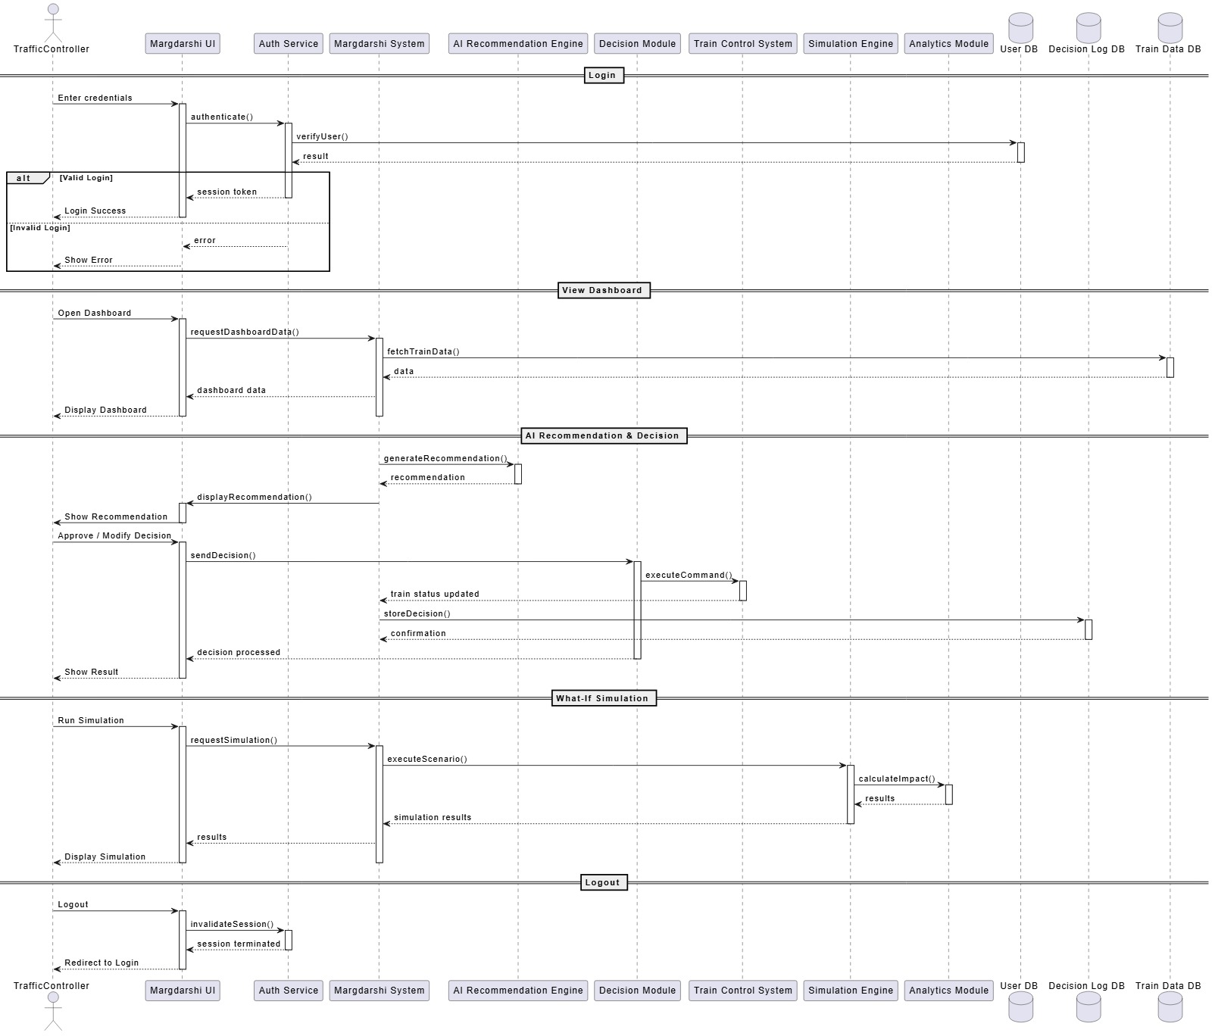

5.2 Activity Diagram
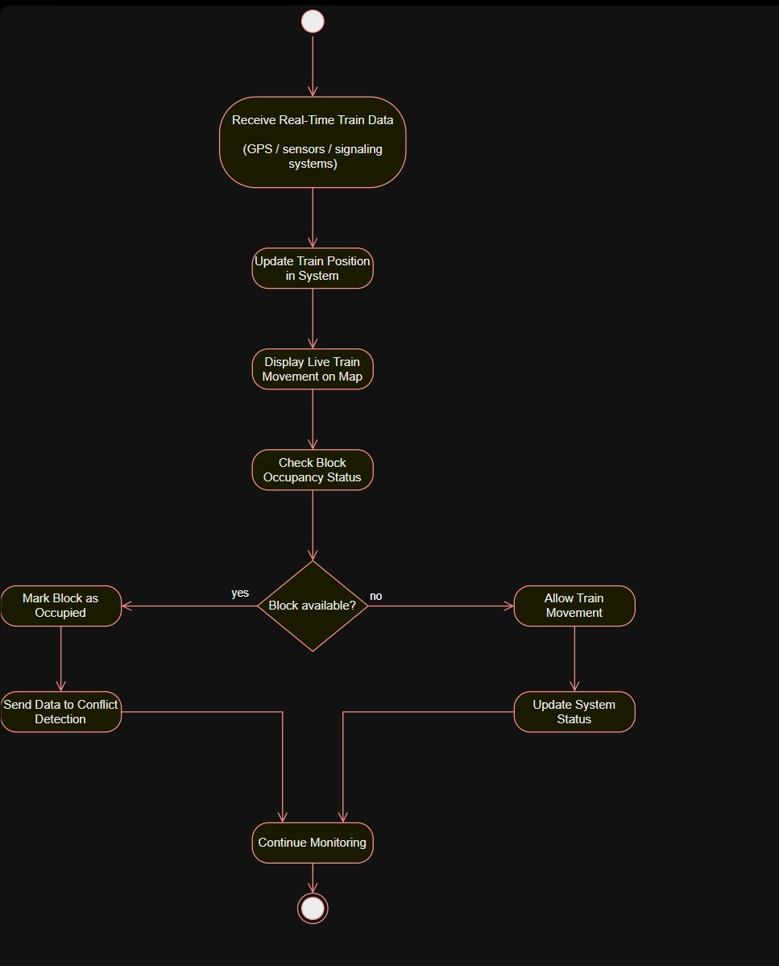

5.3 State Chart Diagram
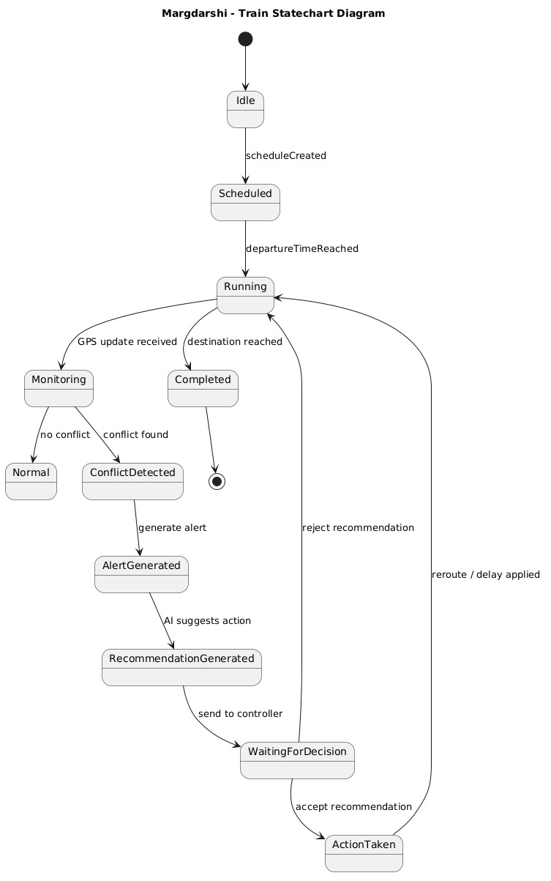

5.4 Use Case Diagram

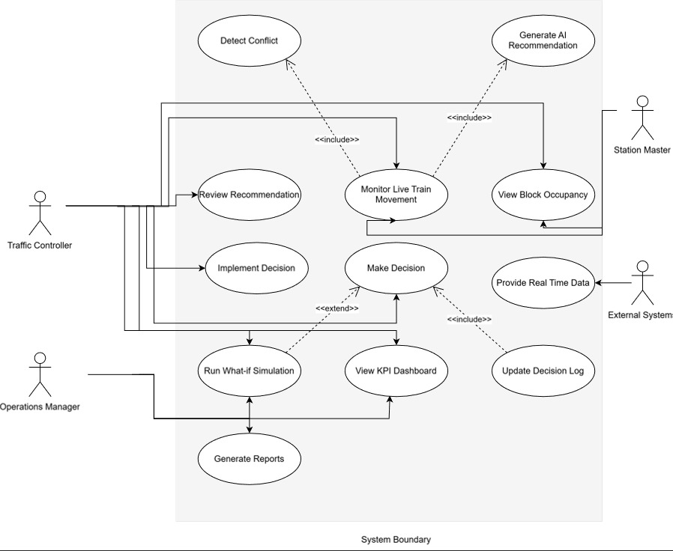

5.5 Data Flow Diagram
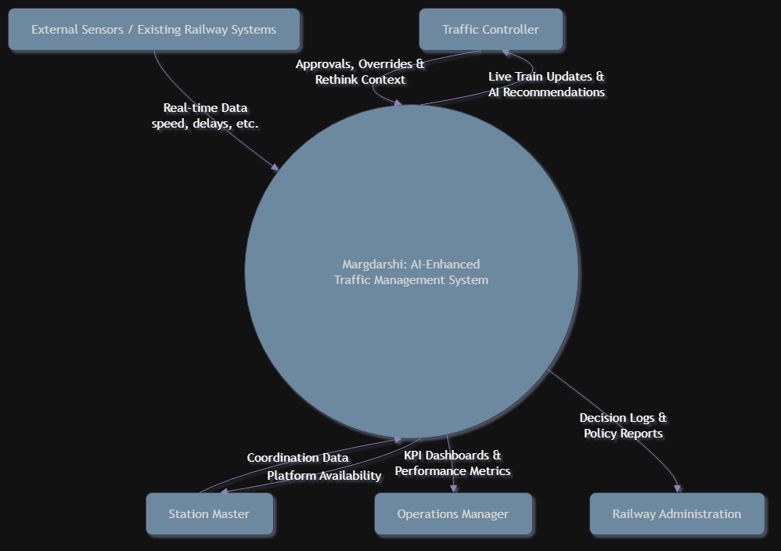

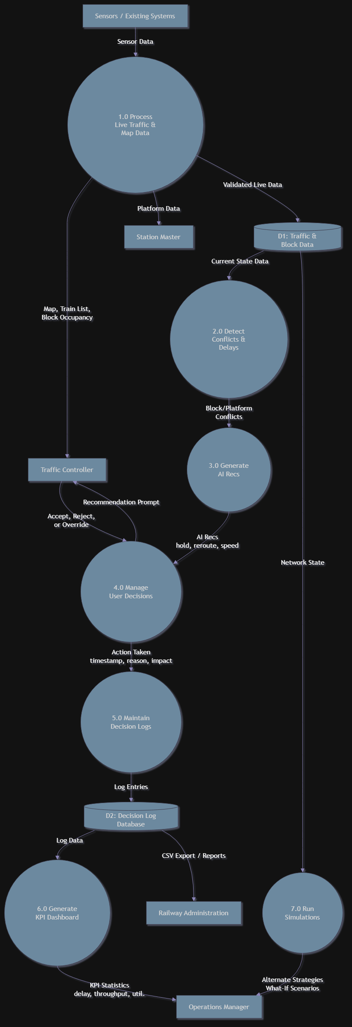

Appendix A – Data Dictionary

Entity Name | Type | Description | Possible States / Values | Related Requirements
Locomotive_ID | Constant | Unique alphanumeric identifier for each train engine. | e.g., "WAP-7-30215" | F1, F7
GPS_Coordinates | Input | Real-time latitude and longitude data from locomotive transceivers. | Pair of Decimals (DD.dddd) | F1, P1
Train_Status | State Variable | The current operational standing of the train relative to the schedule. | On-Time, Delayed, Warning | F1, F6

Entity Name | Type | Description | Possible States / Values | Related Requirements
Block_ID | Constant | Unique identifier for a specific section of railway track. | e.g., "SEC-A1-B04" | F2, F3
Block_Occupancy_State | State Variable | The current physical status of a track block as reported by sensors. | Occupied, Vacant, Maintenance | F2, S1
Conflict_Alert | Output | A  visual/audible notification triggered when overlap is predicted. | TRUE (Active), FALSE (Inactive) | F3, P2, S3
Velocity_MPH | Input | The current speed of the train measured in English units. | 0 to 110 mph | F1, 3.2
AI_Recommendation | Output | Optimization suggestion generated by the machine learning engine. | Text String (Action Card) | F4, S2
User_Action | Input | The decision made by the controller regarding an AI  suggestion. | Accept, Reject, Ignore | S2, 4.3.3

Entity Name | Type | Description | Possible States / Values | Related Requirements
Punctuality_Rate | Output/KPI | Percentage of trains running on schedule within a specific zone. | 0.0% to 100.0% | F6
Simulation_Scenario | Input | Parameters defined by the user for "what-if" testing. | e.g., "Block_X_Closed" | F5, P3
Auth_Token | State Variable | Secure session identifier for logged-in users. | Encrypted String | SE1, SE2

Key Definitions for Data Types:
      - Constant: A value that remains fixed (e.g., ID numbers).
      - Input: Data received from external hardware or users.
      - Output: Data or signals produced by the system for the user or external systems.
      - State Variable: A value that changes based on system logic or external events (e.g., Status).

Measurement Units:
As specified in the Hardware Interface section (3.2), all physical measurements are processed using English units (miles per hour, miles, etc.) for internal logic consistency.

Appendix B - Group Log
- Planning Phase: Team identified the problem and objectives, conducted feasibility study (Technical, Economic, Operational).
- Design Phase: Team verified requirements for UML-based system design using use cases.
- Risk Assessment: Team identified risks regarding complexity of constraints and mitigated them via modular OOP design

